**Sprint 4**

|  |  |
| --- | --- |
| **DATE** | **18 november 2022** |
| **TEAM ID** | **PNT2022TMID45918** |
| **PROJECT NAME** | **IOT BASED SMART CROP PROTECTION FOR**  **AGRICULTURE** |
| **MAXIMUM MARK** | **20 MARKS** |

**STEP 1:** MIT App Inventor to design the App

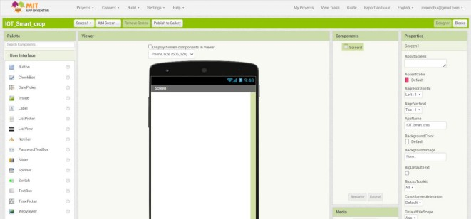

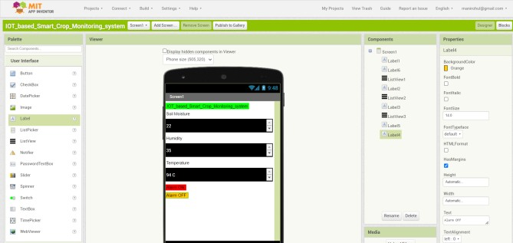**STEP 2:** Customize the App interface to display the values